

**Srajan Institute of Technology Management & Science,**

**Ratlam (M.P)**

**SESSION 2022-2023**

**Minor Project Synopsis**

**On**



**“ Youtube Video Scrapper ”**

*Submitted*

*in partial fulfillment of the requirement for the*

*Degree*

*of Bachelor*

*of Technology*

*in*

*Computer Science & Engineering*

**DEPARTMENT OF**

**COMPUTER SCIENCE & ENGINEERING**

**Submitted To**

**Rajiv Gandhi Prodhyogiki Vishwavidhyalaya,**

**Bhopal (M.P.)**

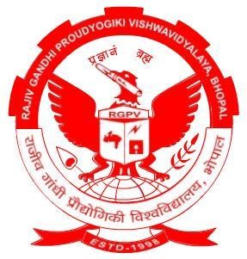

**Submitted To – Submitted By –**

**Miss. Monika Rawat Moh. Sufiyan (0723CS211031)**